Correlation in ML measures the strength and direction of a linear relationship between two variables. It ranges from -1 (perfect negative x values will decrease when y is increased) to +1(perfect positive x,y will increased), with 0 indicating no linear correlation.
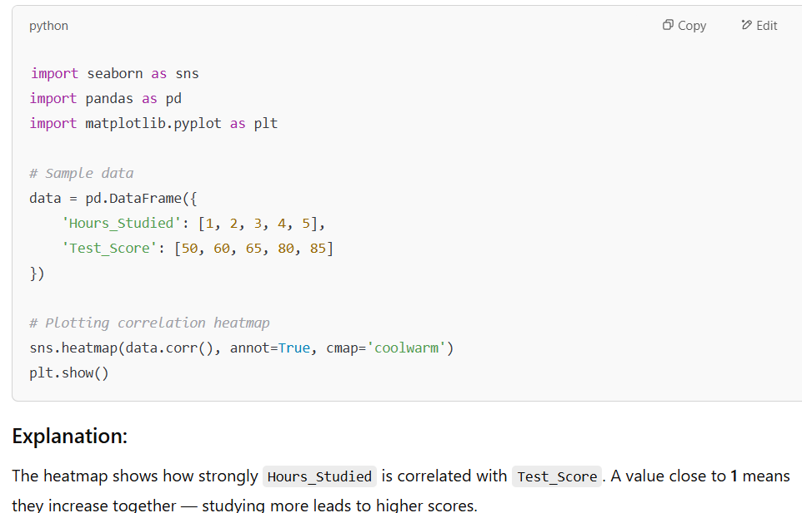

Positive correlation:

Negative correlation:
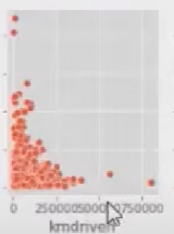

No correlation
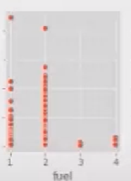
We will take positive and negative correlated fields as input to train a linear regression model.

